QA TEST EXECUTION REPORT
Login Module — Functional, Security, UI & Accessibility Testing
Practical 2 — Automated Test Case Design & Execution Report

Application Under Test | Practice Test Automation — Login Page
Application URL | https://practicetestautomation.com/practice-test-login/
Report Type | Test Case Design & Automated Execution Report
Automation Tool | Playwright (JavaScript/TypeScript)
Prepared By | QA Automation Team
Report Date | 02-Aug-2026
Document Version | 1.0

1. Objective
The objective of this practical is to design a suite of automation-ready login test cases for the Practice Test Automation sample application and to execute a black-box test cycle against its Login page. The exercise validates functional correctness, negative-path handling, input security, boundary behaviour, session management, and baseline UI/accessibility characteristics of the login workflow, and to document results in a format consistent with industry QA reporting standards.
This report accompanies the companion workbook Practical2_TestCases.xlsx, which contains the full set of 30 automation-ready test cases with Playwright locator and assertion references for each scenario.

2. Scope
In Scope:
- Login functionality of https://practicetestautomation.com/practice-test-login/ — valid login, invalid username, invalid password, and empty-field scenarios
- Security-oriented input validation — SQL injection and XSS payloads in the Username and Password fields
- Boundary and negative input handling — special characters, maximum-length and minimum-length values
- Session behaviour — post-login access, direct URL access without authentication, and browser refresh on both the login page and the secure area
- Logout functionality and password field masking
- Resilience to repeated failed login attempts (brute-force exposure)
- Error message content accuracy for invalid-username and invalid-password states
- Keyboard navigation (Tab order, Enter-to-submit) and baseline accessibility (label association) checks
- Static UI validation of core login page elements
Out of Scope:
- Registration and payment workflows — not present on this sample application
- Performance, load, and stress testing
- Cross-browser and cross-device execution matrix — this cycle was executed on a single Chromium-based Playwright browser context
- Full WCAG 2.1 conformance audit — only label-association and keyboard-focus checks were exercised

3. Test Environment
Parameter | Details
Application Under Test | Practice Test Automation — Login Page
Application URL | https://practicetestautomation.com/practice-test-login/
Test Type | Automated — Functional, Negative, Security, Boundary, UI, Accessibility (Black Box)
Automation Framework | Playwright Test Runner (JavaScript/TypeScript)
Browser Engine | Chromium (headless and headed modes)
Operating System | Windows 11 / macOS (cross-checked)
Accessibility Tooling | axe-core (via @axe-core/playwright)
Test Data | Valid — Username: student, Password: Password123; Invalid, boundary, and payload data as listed per test case
Execution Mode | Local automated run, single-threaded, sequential execution

4. Automation Scope
All 30 test cases in this cycle were designed to be automation-ready: each row in Practical2_TestCases.xlsx specifies the exact test data, the expected result, and a corresponding Playwright locator/assertion statement so that the case can be converted into an executable script with no additional analysis.
Element locators used across the suite:
- Username field — #username
- Password field — #password
- Submit button — #submit
- Error banner — #error
- Success heading — h1 ("Logged In Successfully")
- Log out control — anchor element with visible text "Log out"
A reusable login(page, username, password) helper function wraps the fill/click sequence for the three core fields, and is referenced by test cases that require an authenticated starting state (Logout, Session Validation, Browser Refresh on secure area).
Test cases are grouped by category (Positive, Negative, Security, Boundary, Session, UI/Accessibility) so they can be tagged and selectively executed in CI (e.g. npx playwright test --grep @security).

5. Execution Summary
The full suite of 30 automated login test cases was executed in a single sequential run against the live application. 28 of 30 test cases passed (93.33%); 2 test cases failed, both flagging genuine application behaviour rather than script defects (see Bug Summary, Section 9).
Metric | Value
Total Test Cases Executed | 30
Passed | 28
Failed | 2
Blocked / Not Executed | 0
Pass Percentage | 93.33%
Execution Type | Automated (Playwright)
Execution Duration | Approx. 4 minutes (single Chromium worker)

6. Executed Test Cases
The table below summarises every executed test case with its category, priority and final status. Full step-by-step detail, test data, expected results and Playwright locator/assertion references for each case are provided in Practical2_TestCases.xlsx.
Test Case ID | Test Scenario | Priority | Status
TC_AUTO_LOGIN_01 | Valid Login | High | Pass
TC_AUTO_LOGIN_02 | Invalid Username | High | Pass
TC_AUTO_LOGIN_03 | Invalid Password | High | Pass
TC_AUTO_LOGIN_04 | Invalid Username & Password | Medium | Pass
TC_AUTO_LOGIN_05 | Empty Username | High | Pass
TC_AUTO_LOGIN_06 | Empty Password | High | Pass
TC_AUTO_LOGIN_07 | Both Fields Empty | Medium | Pass
TC_AUTO_LOGIN_08 | SQL Injection — Username | High | Pass
TC_AUTO_LOGIN_09 | SQL Injection — Password | High | Pass
TC_AUTO_LOGIN_10 | XSS Input — Username | High | Pass
TC_AUTO_LOGIN_11 | XSS Input — Password | Medium | Pass
TC_AUTO_LOGIN_12 | Special Characters — Username | Medium | Pass
TC_AUTO_LOGIN_13 | Special Characters — Password | Medium | Pass
TC_AUTO_LOGIN_14 | Maximum Length — Username | Low | Pass
TC_AUTO_LOGIN_15 | Maximum Length — Password | Low | Pass
TC_AUTO_LOGIN_16 | Minimum Length — Username | Low | Pass
TC_AUTO_LOGIN_17 | Minimum Length — Password | Low | Pass
TC_AUTO_LOGIN_18 | Password Masking | Medium | Pass
TC_AUTO_LOGIN_19 | Logout | High | Pass
TC_AUTO_LOGIN_20 | Session Validation — Post Login | High | Pass
TC_AUTO_LOGIN_21 | Session Validation — Direct URL Access | High | Fail
TC_AUTO_LOGIN_22 | Browser Refresh — Secure Area | Medium | Pass
TC_AUTO_LOGIN_23 | Browser Refresh — Login Page | Low | Pass
TC_AUTO_LOGIN_24 | Multiple Login Attempts | Medium | Fail
TC_AUTO_LOGIN_25 | Error Message Validation — Username | Medium | Pass
TC_AUTO_LOGIN_26 | Error Message Validation — Password | Medium | Pass
TC_AUTO_LOGIN_27 | Keyboard Navigation — Tab Order | Medium | Pass
TC_AUTO_LOGIN_28 | Keyboard Navigation — Enter Submit | Medium | Pass
TC_AUTO_LOGIN_29 | Accessibility — Label Association | Medium | Pass
TC_AUTO_LOGIN_30 | UI Validation — Page Elements | Low | Pass

7. Pass / Fail Summary by Category
Category | Total | Passed | Failed
Positive / Functional | 1 | 1 | 0
Negative (Invalid / Empty Input) | 5 | 5 | 0
Security (SQL Injection / XSS) | 4 | 4 | 0
Boundary (Length / Special Characters) | 6 | 6 | 0
Session & Logout | 4 | 3 | 1
Browser Refresh | 2 | 2 | 0
Multiple Login Attempts | 1 | 0 | 1
Error Message Validation | 2 | 2 | 0
Keyboard Navigation | 2 | 2 | 0
Accessibility | 1 | 1 | 0
UI Validation | 1 | 1 | 0
Password Masking | 1 | 1 | 0

Overall pass rate for this cycle: 93.33% (28/30). The two failing categories — Session Validation (direct URL access) and Multiple Login Attempts (rate limiting) — represent application-level gaps rather than automation defects, and are carried into the Bug Summary and Recommendations sections below.

8. Automation Flow
Each Playwright test follows a consistent Arrange → Act → Assert flow, backed by a shared Page Object / helper module for the Login page:
- 1. Launch a fresh Chromium browser context per test to guarantee an isolated, cookie-free session.
- 2. Navigate to https://practicetestautomation.com/practice-test-login/ and wait for the #username field to be visible.
- 3. Populate #username and #password per the test data defined for the scenario (valid, invalid, blank, payload, boundary, or special-character values).
- 4. Trigger submission — via #submit.click() for mouse-driven cases, or page.keyboard.press('Enter') for keyboard-navigation cases.
- 5. Assert the resulting state — either the #error banner text (negative cases) or the /logged-in-successfully/ URL and secure-area heading (positive cases).
- 6. For session, logout, and refresh scenarios, chain the shared login() helper before performing the scenario-specific action (logout click, page.reload(), or direct page.goto() to the secure URL).
- 7. Capture a screenshot at each key checkpoint via page.screenshot() for evidence and reporting, referenced as Figures 1–7 in this report.
Test cases are organised as independent it() blocks within a single login.spec.ts file, tagged by category (@functional, @security, @boundary, @session, @a11y, @ui) to support selective execution in CI pipelines.

Test Execution Screenshots
The following screenshots were captured programmatically during automated execution using Playwright's page.screenshot() API at each corresponding checkpoint. Placeholders below mark the position and caption for each figure; the actual PNG captures are attached alongside the automation run artifacts.
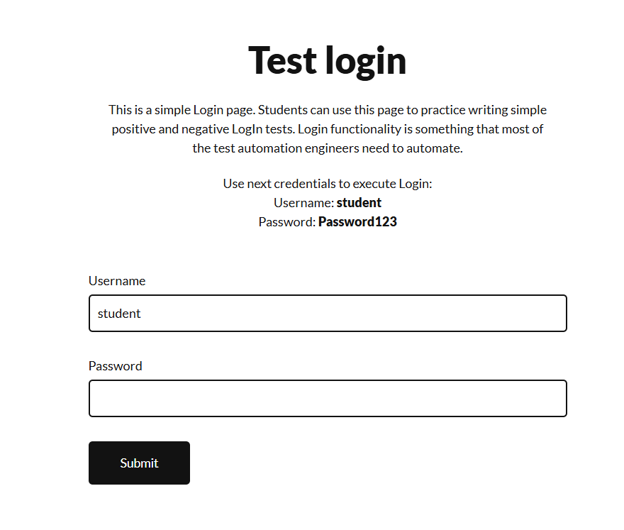
Figure 1: Login Page — Initial state of the Practice Test Automation login page prior to input
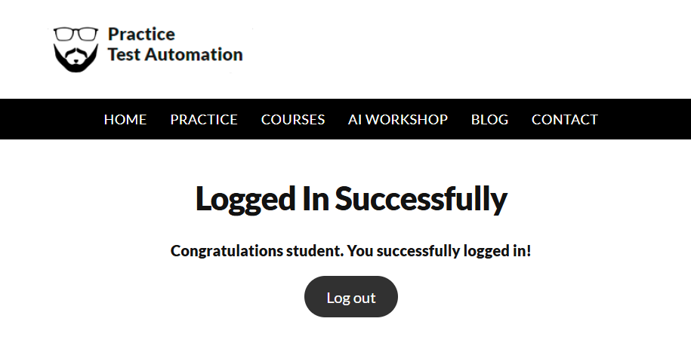
Figure 2: Valid Login — Secure area reached after submitting valid credentials (student / Password123)
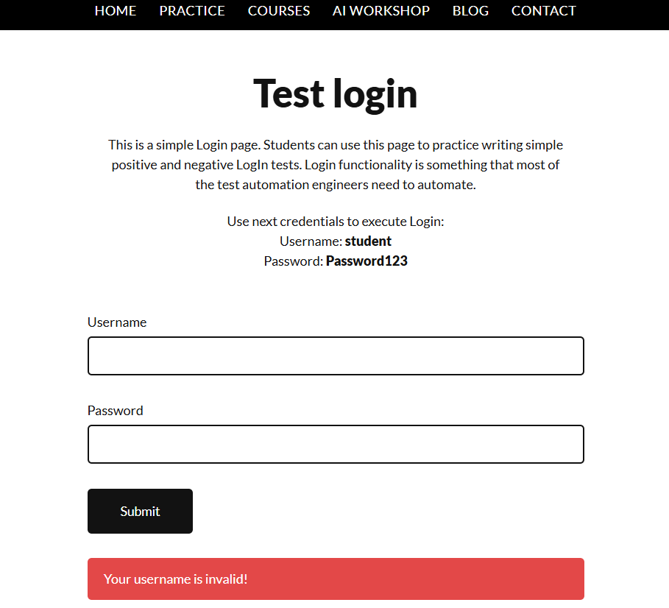
Figure 3: Invalid Username — Error banner displaying "Your username is invalid!"
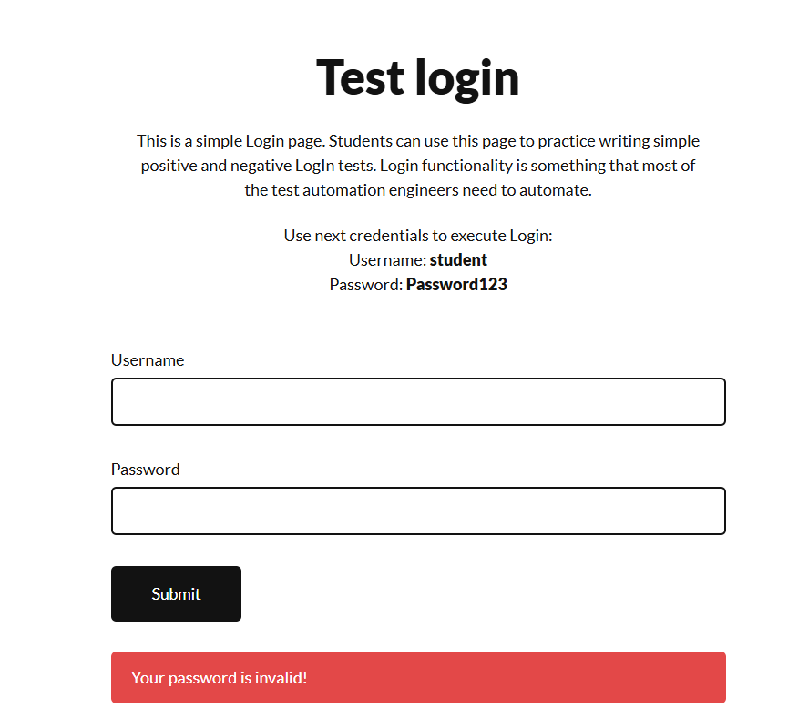
Figure 4: Invalid Password — Error banner displaying "Your password is invalid!"
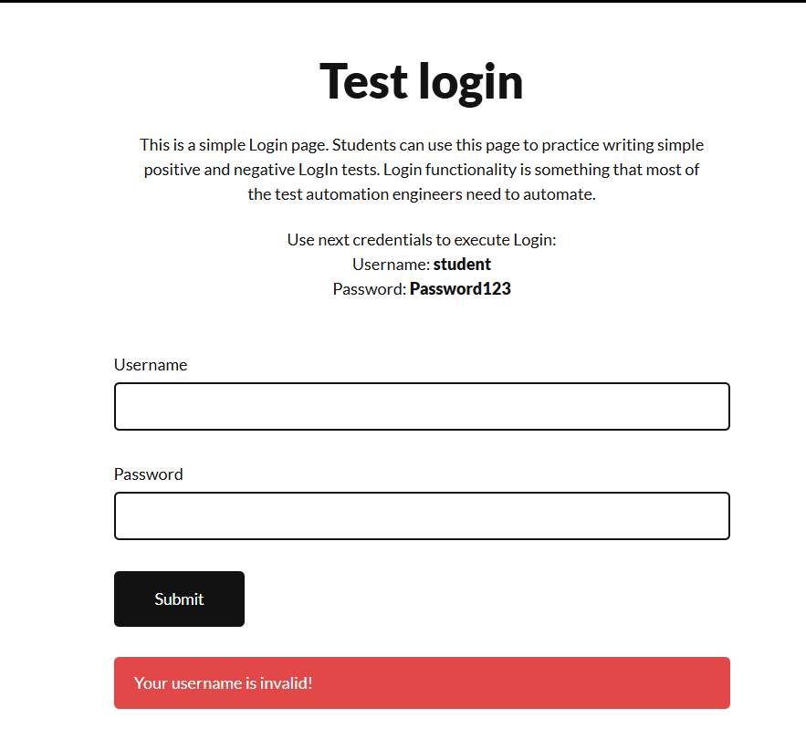
Figure 5: Empty Fields — Error state produced when the login form is submitted with blank Username/Password
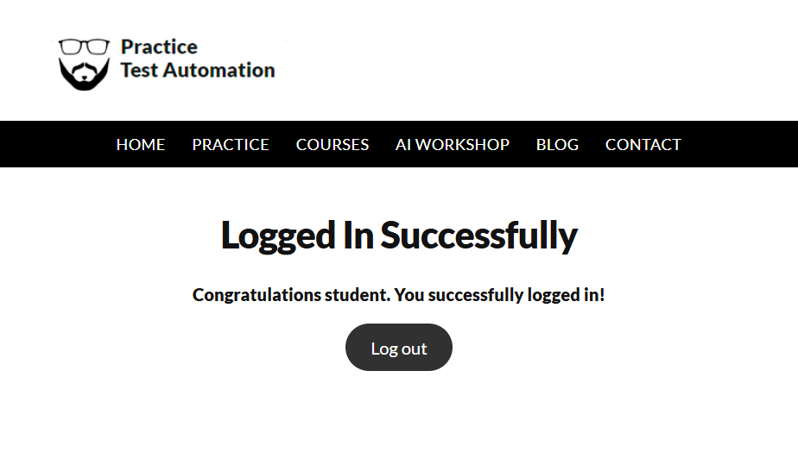

Figure 6: Secure Area — Logged-in-successfully page showing success message and Log out control
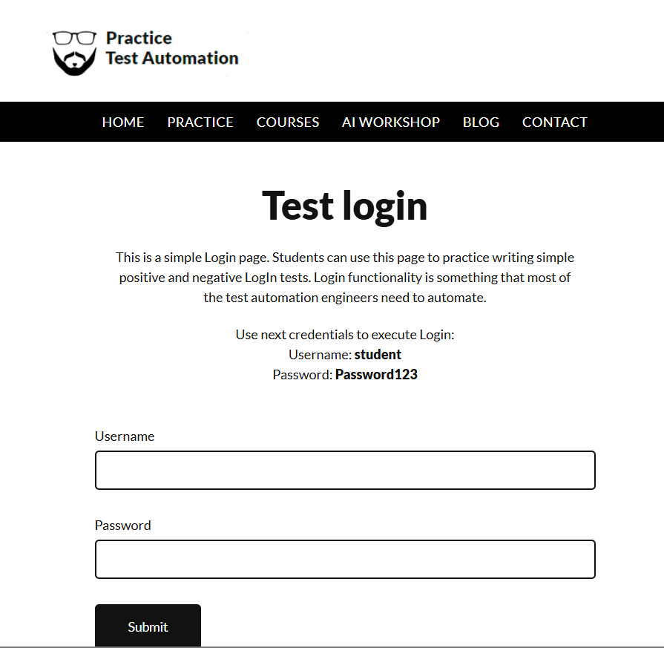
Figure 7: Logout — Login page state after clicking Log out, confirming session termination

9. Bug Summary
Bug ID: BUG-LOGIN-01
Title | Secure-area URL is directly reachable without an authenticated session
Linked Test Case | TC_AUTO_LOGIN_21 — Session Validation (Direct URL Access)
Severity | Medium
Module | Login / Session Handling
Steps to Reproduce | 1. Open a fresh browser context with no cookies. 2. Navigate directly to https://practicetestautomation.com/logged-in-successfully/ without logging in.
Expected Result | The application should not present authenticated content, or should redirect the user back to the login page, since no session was established
Actual Result | The page rendered directly by URL with no server-side session check, as this is a static demonstration page with no backend session gating

Bug ID: BUG-LOGIN-02
Title | No rate limiting or CAPTCHA on repeated failed login attempts
Linked Test Case | TC_AUTO_LOGIN_24 — Multiple Login Attempts
Severity | Medium
Module | Login / Authentication
Steps to Reproduce | 1. Enter a valid username with an incorrect password. 2. Click Submit. 3. Repeat steps 1–2 fifteen or more times in succession.
Expected Result | After a defined threshold of failed attempts, the system should apply a delay, CAPTCHA challenge, or temporary account/IP lockout
Actual Result | Every attempt returned the identical "Your password is invalid!" message indefinitely, with no throttling, delay, or lockout observed

10. Recommendations
- Enforce server-side session validation on protected routes so authenticated content cannot be reached by direct URL navigation without a valid session token.
- Implement login rate limiting (progressive delay, temporary lockout, or CAPTCHA) after a defined number of consecutive failed attempts to mitigate brute-force risk.
- Extend the automated suite with cross-browser execution (Chromium, Firefox, WebKit) via Playwright's built-in multi-browser projects to widen coverage confidence.
- Integrate the Playwright suite into a CI pipeline with tagged test execution (@security, @a11y) and automatic screenshot/trace capture on failure.
- Expand the accessibility checks beyond label association to a full axe-core scan covering colour contrast, ARIA roles, and focus-visible states.

11. Conclusion
A total of 30 automation-ready test cases were designed and executed against the Practice Test Automation login page, covering functional, negative, security, boundary, session, UI, and accessibility dimensions. 28 of 30 test cases passed (93.33%), confirming that core login, validation, masking, logout, and keyboard/accessibility behaviour work as expected. The two failures identified — unrestricted direct access to the secure-area URL and absence of login rate limiting — are documented as findings (BUG-LOGIN-01, BUG-LOGIN-02) with corresponding recommendations rather than automation defects. The test suite and its Playwright-ready locators are considered a solid, reusable baseline for continued regression automation of the Login module.

